**iRevolution: A Data-driven Exploration of Apple's iPhone Impact in India using Tableau**

**Dashboard 1:**

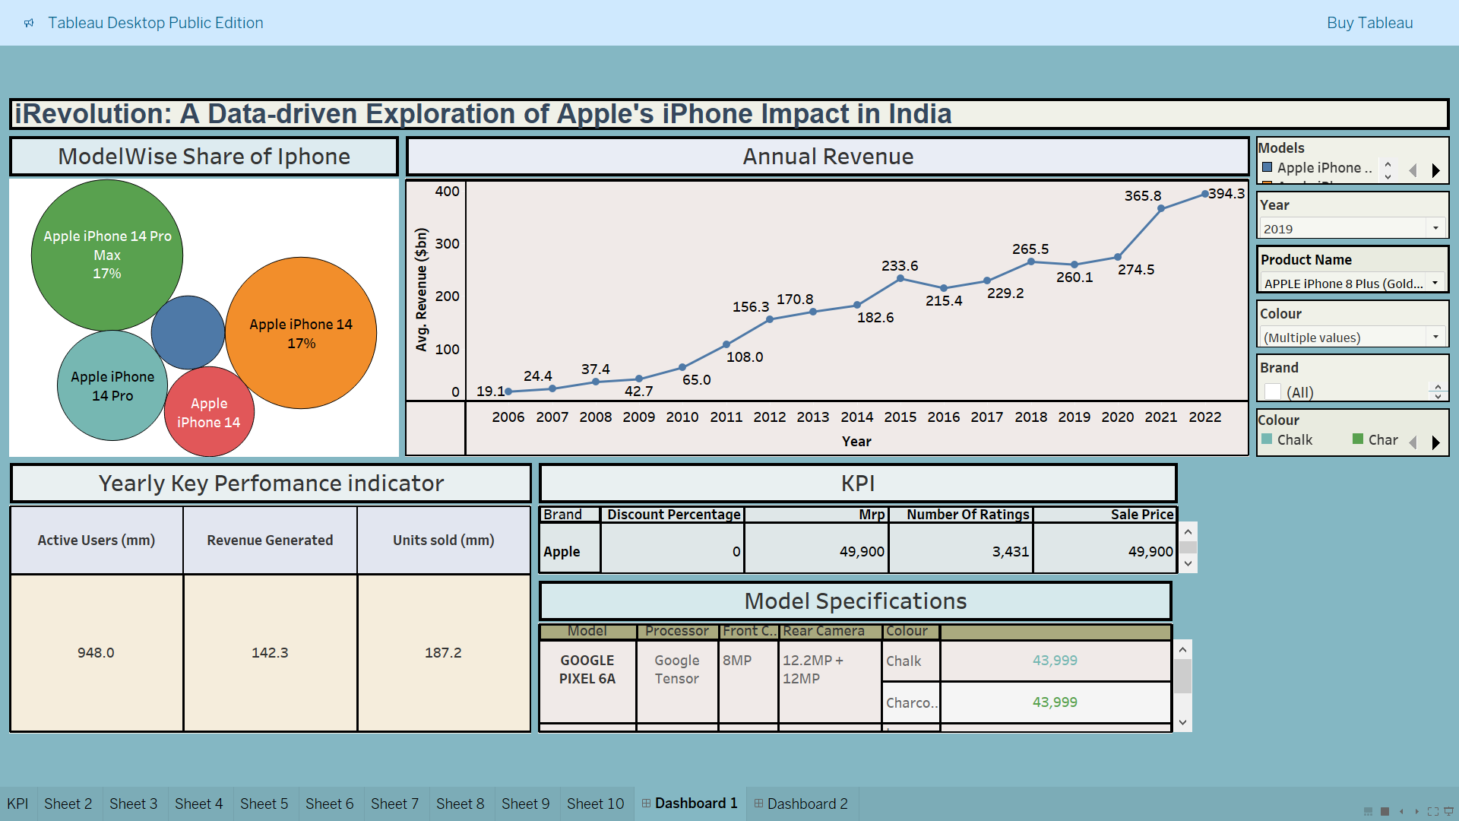

**Dashboard 2:**

